IEEE IAS Petroleum and Chemical Industry Committee
2019 Awards Luncheon
11:45 a.m. – 1:30 p.m.

Welcome and Introduction of Head Table Dennis Bogh
and PCIC Executive Subcommittee PCIC Chair

Recognition of Past Chair and Past Advisory & Awards Dennis Bogh

Peter Baen | PCIC Chair
Louis Barrios | Advisory & Awards

Recognition of Outgoing Subcommittee Chairs Dennis Bogh

Bill Veerkamp | Awards Nominating
Bob Potter | Facilities Planning
Ken McFarland | Publicity
Miriam Blazowski | Membership
Jeff Gaspar | Young Engineers Development
Shahid Jamil | Safety
Donna Hodgson  Mark Throckmorton  Eddie Guidry  Troy Parvino | Production
Mark Throckmorton | Chemical
Todd Huston | Transportation
Nic Leblanc | International

Myron Zucker Grant Recipients Dennis Bogh

Atul Arunkumar Shenoy Ian Pollard
Brendan Gunderson Josiah McNulty
Irina Vaseva Daniel Floyd

Eugene J Fagan PCIC Fund Louis Barrios
Fund Subcommittee Chair

Prize Paper Awards Peter Baen
Advisory and Awards Subcommittee Chair

Outstanding Technical Contribution Award Jim Bowen
John A. Kay PCIC Vice Chair

Emeritus Award for Outstanding Service Leo Berg
Chet Sandberg Emeritus Chair

Electrical Safety Excellence Award Shahid Jamil
John Nelson Safety Subcommittee Chair

Outstanding Young Professional Achievement Award Jeff Gaspar
Clifton Oertli YEDS Chair

Recognitions of IEEE Standards Completion Robert Durham
Standards Subcommittee Chair

Dwight Alexander | IEEE 45.4 Recommended Practice for Electrical Installations on Shipboard - Marine Sectors and Mission Systems
Yuri Khersonsky | IEEE 1708-2018 Recommended Practice for 1 kV to 35 kV Medium-Voltage DC Power Systems on Ships
Roy Barth | IEEE/CSA 844.3 Standard for Impedance Heating of Pipelines and Standard Equipment - General, Testing, Marking, and Documentation Requirements
Roy Barth | IEEE/CSA 844.4 Standard for Impedance Heating of Pipelines and Equipment - Application Guide for Design, Installation, Testing, Commissioning, and Maintenance
Kevin Petersen | IEC/IEEE 80005-1:2019 Utility connections in port – Part 1: High voltage shore connection (HVSC) systems – General requirements
Daleep Mohla | IEEE 1584 - Guide for Performing Arc-Flash Hazard Calculations
IEEE 1584 “team”  IEEE Standards – Dr. Ing. Konstantinos Karachalios  - Matthew Ceglia  - Patricia Roder  - Lisa Perry  IEEE PCIC - Thanks to the entire Working Group |  | Dennis Bogh

IAS President-elect Dr. Wei-Jen Lee

IAS President-Elect

IEEE Fellow Dr. Wei-Jen Lee

John Malinowski

IEEE Fellow Dr. Wei-Jen Lee

Dr. Robert Durham

David C. Azbill Award Dennis Bogh

John Turner

Russell W. Mills Award Dennis Bogh

Louis Barrios

Closing Remarks Dennis Bogh

PRIZE PAPER AWARDS

for the

2018 IEEE/IAS PCIC Technical Conference, Cincinnati, OH

BEST PAPER
IEEE C37.20.7 Guide for Testing Switchgear Rated Up to 52kv for Internal Arcing Faults – Important Changes to The New Edition
Michael Wactor
SECOND BEST PAPER
Grounding and Bonding Conductors: Solid, Stranded, Bare or Insulated?
Robert Durham, Stephen Szczecinski, Marcus Durham
THIRD BEST PAPER
Strategies for Reliable Arc Flash Protection in Low-Voltage Switchgear
Robert Burns, Adams Baker, Dan Hrncir
HONORABLE MENTION
Harmonic Analysis of Arcing Faults and Impacts On System Protection
Dane Martindale, Jeremy Smith

A Motor Primer – The Next Generation: Permanent Magnet Machines
Robert McElveen, Nicolas Frank, William Martin, Jukka Jarvinen

Substations in Classified Locations, Integration of NFPA 496 Pressurization Requirements with Other Supporting Systems
Giovanni Parra, Joshua Komathy, Gregory Clement, Richard Anderson Jr.

®
2019
Awards
Luncheon
 | 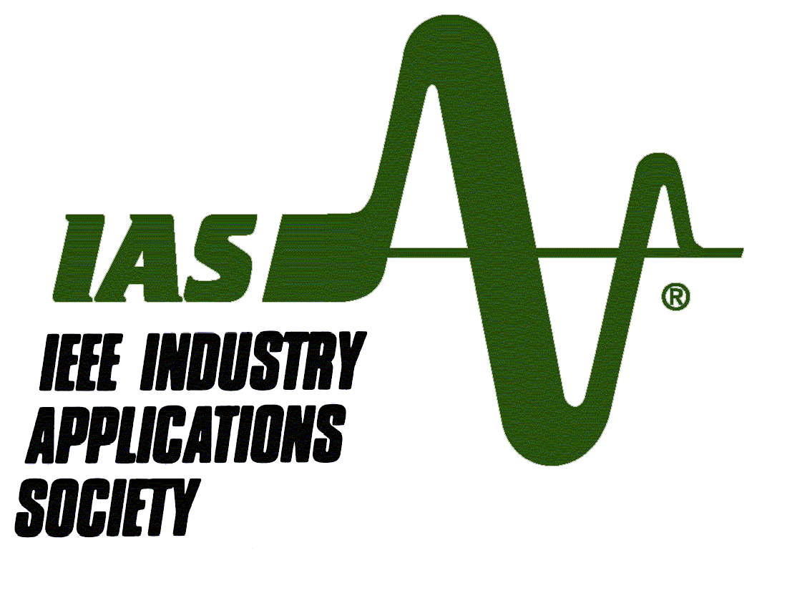 | Monday, September 9th  Vancouver 2019 Conference

